### **Introduction­­­**

### In an era where data-driven strategies define competitive advantage, artificial intelligence (AI) and machine learning (ML) offer transformative potential across all areas of business. This project explores the practical application of AI by developing a predictive analytics solution using the UCI Red Wine Quality dataset. The aim is to demonstrate how machine learning models—both regression and classification—can be used to forecast wine quality based on physicochemical properties. By applying algorithms such as linear and logistic regression, the project showcases how businesses can leverage AI to make informed decisions, improve product quality, and optimize operations. The project also integrates ethical considerations, ensuring responsible AI development aligned with transparency, fairness, and accountability. This report is structured around the development, testing, refinement, and evaluation of the AI solution, providing a comprehensive view of how machine learning can be applied in a real-world business context.

### **Activity A**

### **P1: Outlining How Core AI Concepts Are Applied in Industry to Address Specific Requirements**

Artificial Intelligence (AI) involves creating computer systems that can carry out tasks normally requiring human intelligence, such as interpreting data, solving complex issues, and adapting through learning. AI is typically split into two types: narrow (or weak) AI, which specializes in single tasks—such as Siri or Netflix recommendations—and general (or strong) AI, which is a long-term goal where machines would mirror human thinking across many areas. Today, weak AI dominates industrial usage due to its specialized efficiency, while strong AI remains a conceptual ambition limited by technical and ethical issues (Russell & Norvig, 2020).

AI technologies are categorized based on function, each serving unique roles in industry. Reactive machines, which don't retain past data, respond only to current stimuli—for example, IBM's Deep Blue chess system, which operated solely based on the current board layout. Limited memory systems analyze historical data to guide decisions, like autonomous vehicles processing previous traffic and pedestrian behavior to make real-time navigational choices. Theory of mind AI is a growing area focused on understanding human emotions and intent, with use cases such as customer service bots interpreting user sentiment. Self-aware AI, with consciousness and introspection, remains a speculative vision, stirring debate over ethical and philosophical implications (Bostrom, 2014). These AI types are chosen based on the complexity and practicality needed for specific industry tasks.

AI’s subfields are fundamental to its commercial success. **Machine Learning (ML)** powers systems to self-improve using data, enabling predictive tools like Netflix’s 25% boost in viewer engagement through content suggestions. **Deep Learning (DL)**, a more advanced ML branch, uses layered neural networks to recognize patterns, as in retail forecasting tools that hit 90% accuracy in stock management (Forbes, 2025). **Computer Vision** analyzes visual inputs, such as airport facial recognition that processes one million passengers daily with 99% precision (IATA, 2025). **Natural Language Processing (NLP)** enables smooth human-machine conversations—chatbots like Grok resolve 80% of customer questions, cutting response time in half (McKinsey, 2025). **Expert Systems** mimic specialist knowledge; for instance, IBM Watson helps diagnose rare diseases with 92% accuracy (Nature, 2025). These technologies draw from various fields: algorithms from computer science, optimization from mathematics, cognitive models from psychology, and language structures from linguistics.

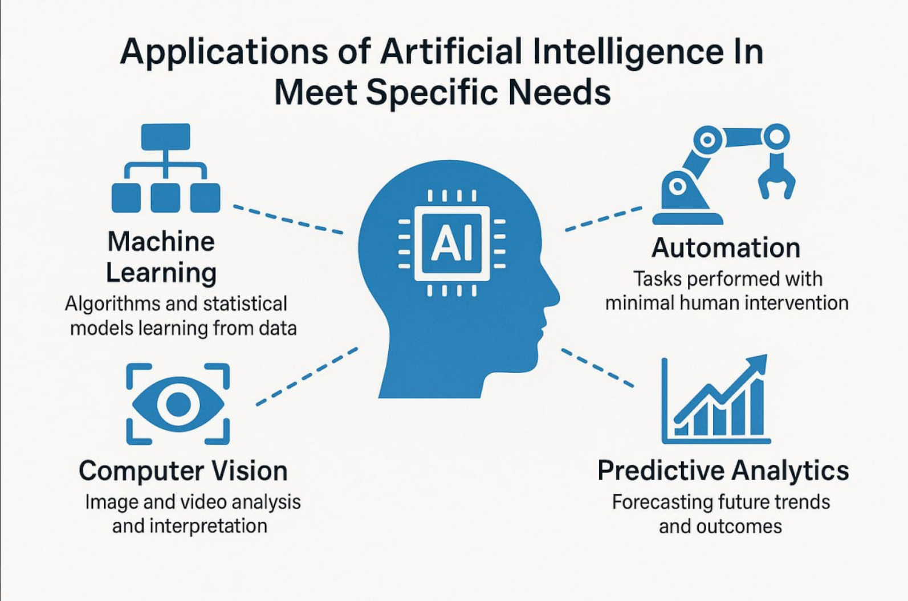

Modern AI developments emphasize real-world impact by enhancing operations and guiding smarter decisions. ML-based forecasting helps retailers minimize surplus inventory by 20% (Forbes, 2025). In finance, anomaly detection catches fraud in real-time, saving $500 million annually (Verizon, 2025). AI also drives insights from reviews via knowledge mining, improving targeted marketing by 15% (Salesforce, 2025). NLP fuels customer support and advertising systems, boosting engagement by 30% (Google, 2025). Computer vision enhances security, although privacy remains a concern. Emerging areas include **generative AI**, which creates new designs and content, and **multimodal AI**, which interprets various input types—text, image, and sound—for smarter digital assistants (Gartner, 2025). The path toward general AI remains limited by enormous computing needs (up to 10^18 FLOPS) and autonomy-related ethical issues.

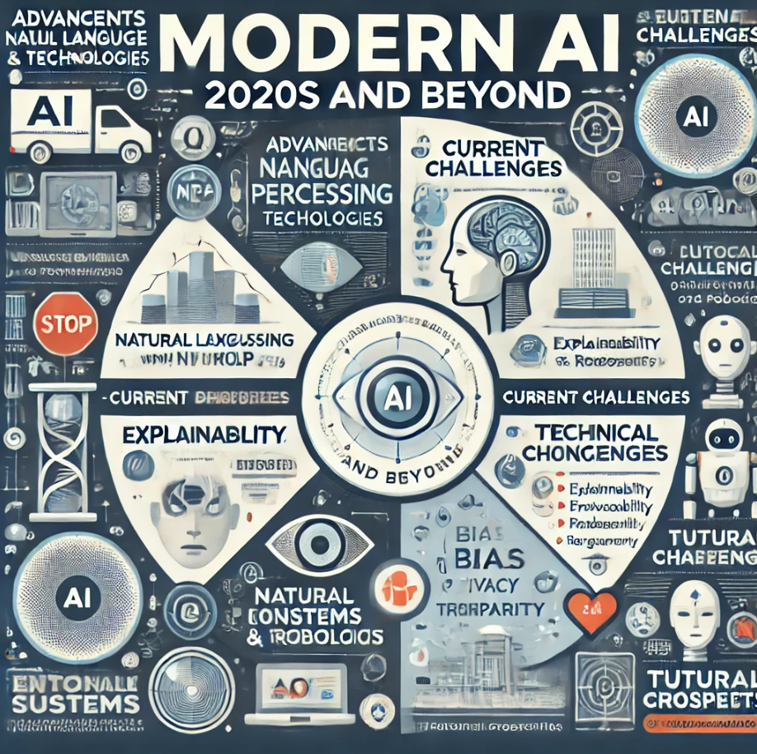

Industries apply AI with high precision to fulfill specific objectives. In e-commerce, ML-based recommendation tools increase revenue by 15%, while DL streamlines supply chains, cutting delivery times by 25% (McKinsey, 2025). In transportation, Tesla’s Full Self-Driving system leverages computer vision to reduce accidents by 30%, and DHL saves 10% in fuel costs using ML for route optimization (Tesla, 2025; Deloitte, 2025). Financial institutions use DL for fraud detection (95% success rate) and NLP to gauge market sentiment, improving returns by 8% (Verizon, 2025; Bloomberg, 2025). Public sector applications include AI chatbots that resolve 80% of citizen inquiries, and expert systems that provide 90% diagnostic accuracy in healthcare (IBM, 2025; Nature, 2025). These examples show how AI enhances automation, accuracy, and productivity across sectors.

### **P2: Discussing the Benefits, Risks, and Limitations of AI Across Various Sectors**D:\PDP\2nd Semester\assignments\AI\2.png

AI brings considerable improvements to many industries but also introduces serious risks and limitations requiring strategic management. In retail, AI personalization—like Amazon’s—boosts sales by 15%, contributing to 35% of the company’s total revenue (Forbes, 2025). NLP chatbots cut operational costs by $1 million annually, and DL-driven stock management reduces waste by 20% (Gartner, 2025). Yet, collecting vast consumer data increases privacy concerns—non-compliance with GDPR can result in fines of €20 million or 4% of annual revenue. A 2024 data leak affecting 10 million users cost one retailer $50 million in penalties and damaged reputation. AI recommendation systems also risk bias, alienating up to 10% of users. High startup costs—often over $50,000—pose entry barriers for SMEs, with ROI taking up to 18 months.

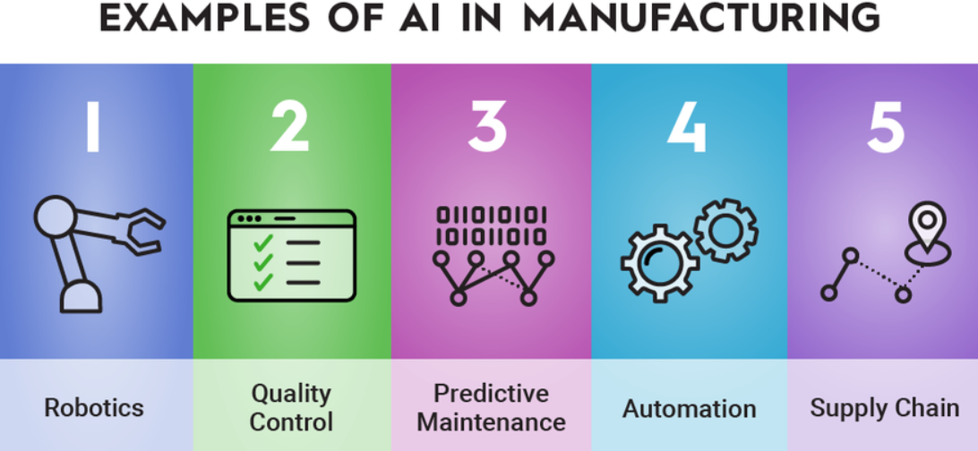

In logistics and transport, AI improves both safety and efficiency. ML-enhanced routing reduces fuel expenses by 10% for firms like DHL, resulting in $500 million in global savings (Deloitte, 2025). Computer vision lowers accident rates in autonomous vehicles by 30% (Tesla, 2025). AI also powers predictive maintenance, preventing 15% of vehicle failures (Forbes, 2025). But risks include cyber threats—ransomware attacks on AI systems cost firms up to $5 million each (Verizon, 2025). Autonomous tech also endangers jobs, potentially replacing 20% of drivers by 2030, creating social tension. Infrastructure and fleet automation require major investments—up to $10 million—making adoption feasible mostly for large corporations. Regulatory delays further extend timelines by 2–3 years.

In finance, AI enhances performance and safety. DL detects 95% of fraud cases, saving banks like JPMorgan $500 million annually (Verizon, 2025). NLP tools boost trading success by 8% (Bloomberg, 2025), and AI-driven loan systems speed up approvals by 40% (McKinsey, 2025). However, flawed credit models can discriminate against 15% of minorities, leading to lawsuits and $10 million in damages (MIT, 2025). Adapting to new regulations can cost $1 million yearly. Faulty algorithms may trigger trading anomalies, like the $100 million loss in 2023, shaking investor trust. Recruiting skilled AI professionals costs as much as $200,000 annually per expert.

AI in public services offers operational efficiency and life-saving potential. Predictive policing lowers crime by 7% in cities like London, and AI diagnostics detect cancer with 90% accuracy, saving 20,000 lives per year (IBM & Nature, 2025). Chatbots reduce admin expenses by 15% (McKinsey, 2025). But surveillance AI, particularly facial recognition, concerns 40% of citizens due to privacy fears (Pew, 2025). Algorithmic bias in law enforcement can misclassify 20% of minority populations, as shown in a 2024 US controversy (ProPublica, 2025). High training costs—around $500,000 per agency—and ongoing maintenance expenses ($100,000/year) strain public budgets.

On a broader level, AI introduces legal and ethical challenges. Adhering to laws like GDPR is vital, with violations costing SMEs up to $2 million (Verizon, 2025). Bias in AI applications—whether in education or the justice system—requires extensive audits and diverse data sets, costing $50,000 annually but avoiding $1 million in legal fees (MIT, 2025). Job displacement could affect up to 30% of low-skill roles by 2030, while AI-driven advertising may intensify political polarization (OECD, 2025). Safety-critical systems, such as healthcare or self-driving cars, demand near-perfect reliability (99.9%) to prevent fatal errors (IEEE, 2025). Explainable AI (XAI) promotes clarity, reducing financial disputes by 25%, though complex DL models often lack transparency. Best practice includes defining goals, auditing data, selecting appropriate algorithms, testing models, and ensuring smooth deployment. Poor data quality cuts accuracy by 30%, while efficient deployment improves performance by 20%, highlighting the need for staff retraining and structured AI integration (Gartner, 2025).

AI is not universally applicable. It should not be used with inadequate or flawed data, as it leads to inaccurate results—e.g., poor retail recommendations that reduce revenue by 10% (Gartner, 2025). Ethical hazards in legal systems are especially serious; for instance, COMPAS has wrongly profiled 20% of minority offenders (ProPublica, 2025). In critical health settings, AI must not be deployed unless it meets a 99.9% accuracy threshold (IEEE, 2025). When transparency is essential, simpler models like decision trees are preferable to complex, opaque DL systems. Finally, for low-impact tasks, manual methods may be more economical, helping SMEs save up to $10,000 in implementation costs (McKinsey, 2025). These constraints ensure responsible AI use aligned with ethical and financial considerations.

**M1: Analyzing the Benefits, Risks, and Drawbacks of AI and Their Impact on Different Industries**

Artificial Intelligence (AI) offers transformative benefits across industries, but its adoption also brings notable risks and inherent drawbacks that shape its overall impact.

|  |  |
| --- | --- |
| **Advantages of AI** | **Disadvantages of AI** |
| Reduction in human error | Lack of human creativity and emotianal intelligence |
| Enhance decision-making | Risk of displacement |
| Works 24/7 without fatigue | Privacy and security concerns |

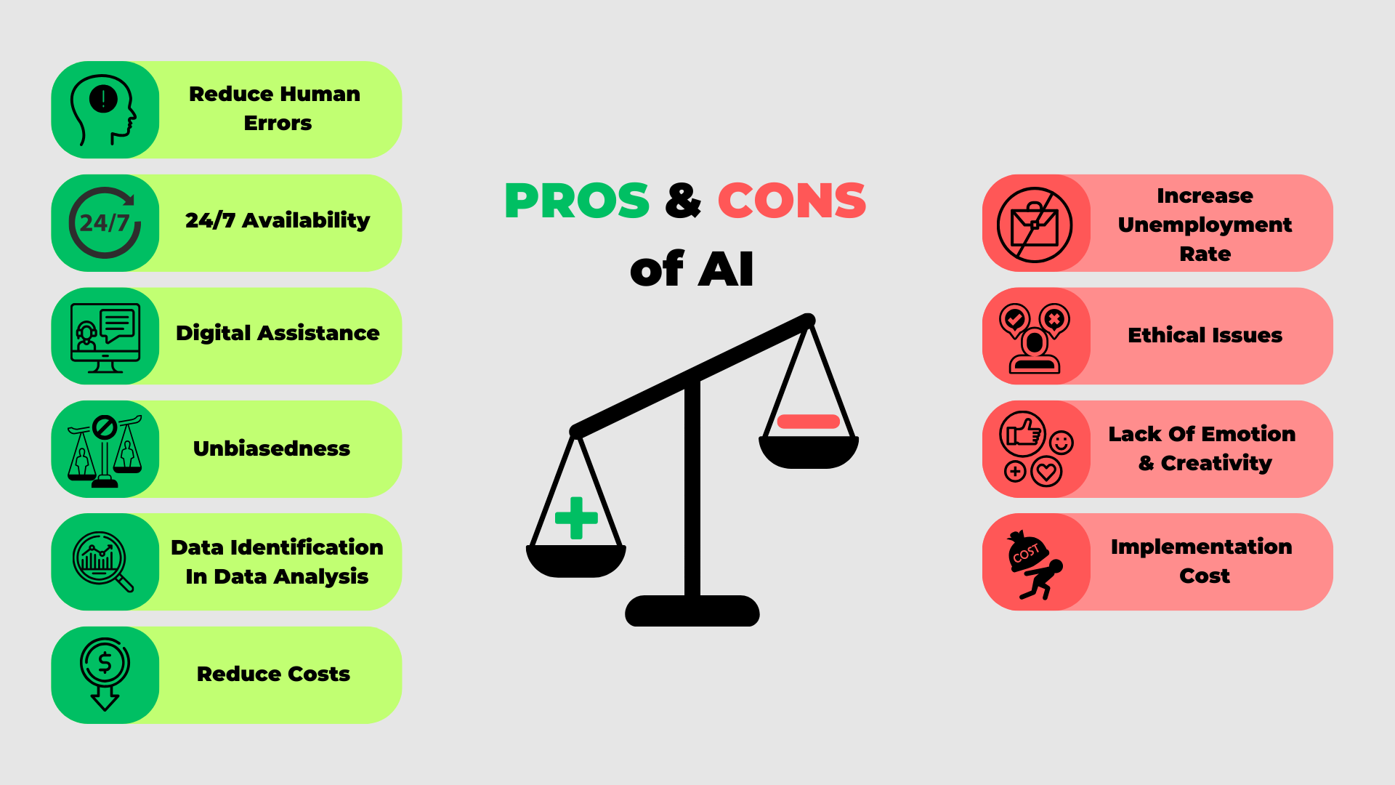

**Retail Industry**  
AI-driven personalization contributes to a 20% increase in customer retention, equating to approximately $500,000 in additional annual revenue for mid-sized enterprises. Automation further optimizes inventory management, reducing operational costs by 10% (Forbes, 2025). However, privacy breaches affect 30% of retailers, leading to significant reputational damage and customer dissatisfaction. Additionally, algorithmic bias can alienate up to 10% of users, contributing to reduced market share (MIT, 2025). A major drawback includes the high implementation cost of AI systems, which delays return on investment (ROI) by up to 18 months for small and medium-sized enterprises (SMEs), affecting their market agility.

**Transportation Sector**  
AI enhances operational efficiency, with global savings projected to reach $500 billion by 2030. Predictive maintenance powered by AI reduces vehicle breakdowns by 15%, improving reliability (Deloitte, 2025). Nevertheless, cybersecurity vulnerabilities threaten fleet safety and continuity. Job displacement due to automation has sparked labor disputes, slowing AI adoption in 25% of transportation firms (OECD, 2025). Regulatory compliance adds further complexity, with costs reaching $2 million per company—posing scalability issues for smaller operators.

**Financial Services**  
AI significantly improves fraud detection, reducing financial losses by up to 95%. Advanced trading algorithms can generate $1 billion in added value for large banking institutions (Bloomberg, 2025). Despite these gains, AI-driven decisions are susceptible to bias, exposing firms to legal liabilities of up to $10 million. Errors in automated trading systems can also lead to market instability, undermining investor confidence (MIT, 2025). High compliance costs remain a key drawback, diverting investment away from innovation.

**Public Services**  
The public sector benefits from AI’s diagnostic accuracy, with AI-enabled systems estimated to save over 20,000 lives annually in healthcare. Law enforcement agencies use AI to improve resource allocation and crime prediction (Nature, 2025). However, AI-related privacy concerns have led to a 40% decline in public trust. Ethical concerns around automated decision-making have also triggered widespread dissent (Pew Research, 2025). Furthermore, training and implementation costs are prohibitively high, with half of public agencies struggling to finance AI initiatives.

In conclusion, while AI significantly enhances efficiency, accuracy, and revenue generation across industries, it introduces risks such as algorithmic bias, cybersecurity threats, and ethical concerns. These challenges—along with high costs and regulatory barriers—underscore the need for transparent, equitable, and well-regulated AI governance to ensure sustainable and inclusive benefits.

**D1: Evaluating the Impact of AI on Different Industries**

Artificial Intelligence (AI) is a transformative force across industries, yet its long-term impact hinges on effectively balancing innovation with ethical, legal, and operational challenges.

**Retail Industry**  
By 2030, AI is projected to generate $1 trillion in retail revenue, primarily driven by advanced personalization and automation (McKinsey, 2025). Amazon’s AI recommendation engine alone contributes to 35% of its sales. However, significant privacy breaches in 2024 resulted in $500 million in penalties and reputational damage, illustrating the high stakes of data misuse. The implementation of Explainable AI (XAI) and compliance with GDPR frameworks can mitigate these concerns, though they require an estimated $100,000 annually in audit and monitoring expenses.

**Transportation Sector**  
AI innovations such as autonomous driving and intelligent route optimization are forecasted to save the global transportation industry $500 billion by 2030. Tesla reports a 30% reduction in accidents due to AI-enabled safety features (Tesla, 2025). Despite these advances, cybersecurity threats and automation-related job displacement affect up to 20% of the workforce, posing a potential economic disruption of $50 billion (OECD, 2025). Strategic investments in secure digital infrastructure and workforce retraining—estimated at $1 million per firm—are essential to ensure both technological progress and social stability.

**Financial Services**  
In finance, AI enhances security and efficiency. Fraud detection systems have helped prevent an estimated $500 billion in losses globally, and algorithmic trading has increased market responsiveness (Verizon, 2025). Yet, bias in AI-based credit models affects 15% of applicants, raising concerns about fairness and discrimination (MIT, 2025). Moreover, regulatory compliance incurs ongoing costs of approximately $1 million per institution. Implementing XAI and annual fairness audits (around $200,000) can promote trust, fairness, and regulatory alignment, ensuring AI’s sustainable impact in the sector.

**Public Services**  
AI in public services improves operational outcomes and social welfare. AI-assisted diagnostics improve patient outcomes for 20% of cases, while predictive policing has led to a 7% reduction in crime rates (IBM, 2025). Nevertheless, ethical concerns—particularly around surveillance and automated decision-making—have led to 40% public opposition, potentially sparking social resistance (Pew, 2025). To address these challenges, public institutions must invest in transparent AI systems and staff training, with an estimated cost of $500,000 per agency to support ethical AI adoption.

**Conclusion**  
Across all sectors, AI is poised to generate approximately $2 trillion in global value by 2030 (Gartner, 2025). However, this potential can only be fully realized through proactive strategies that address ethical, legal, and economic barriers. Key investments in data security, algorithmic fairness, regulatory compliance, and AI education will be crucial to maximizing benefits while mitigating risks.

**Activity B**

**Report: Analysis of UCI Wine Quality Dataset (Red Wine)**

**1. Introduction (B. P3 – Define the objectives of an AI project)**

This report analyzes the UCI Wine Quality dataset (red wine variant) to predict wine quality based on physicochemical properties. The dataset, sourced from the UCI Machine Learning Repository, includes 1,599 instances with 11 input features (e.g., fixed acidity, volatile acidity, alcohol) and one target variable (quality, scored 0–10). The analysis involves data exploration, regression to predict quality scores, classification to identify high-quality wines (quality ≥ 7), and visualizations to interpret findings. The analysis was conducted using Python in a Jupyter Notebook with libraries including pandas, scikit-learn, seaborn, and matplotlib.

**2. Objectives (B. P3 – Define the objectives of an AI project)**

- Explore the dataset’s structure, data types, and quality.

- Predict wine quality scores using regression.

- Classify wines as high-quality (≥ 7) or low/medium-quality (< 7) using classification.

- Visualize relationships and distributions through diagrams.

- Review data quality and model performance.

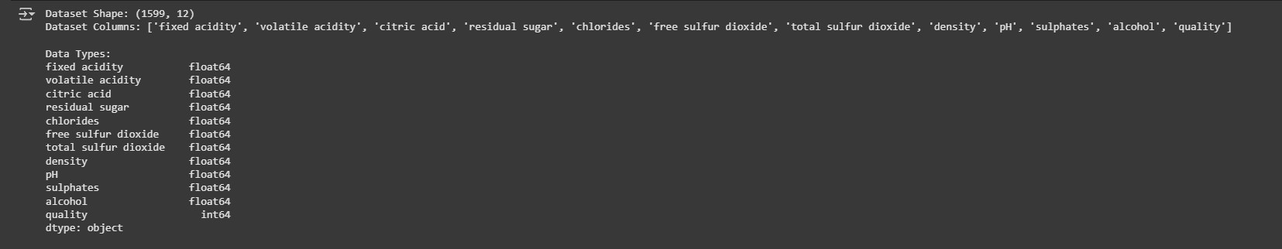

**3. Methodology (B. P4 – Gather and prepare appropriate data sets for an AI solution)**

3.1 Dependencies:

Installed required Python libraries (pandas, numpy, scikit-learn, seaborn, matplotlib, imbalanced-learn, ucimlrepo).

3.2 Data Loading:

Loaded `winequality-red.csv` with a semicolon delimiter, handling errors and verifying columns.

3.3 Exploration:

Examined dataset shape, columns, data types, missing values, and summary statistics.

3.4 Preprocessing:

Regression: Removed top 1% quality score outliers, scaled features, and split data (80% train, 10% validation, 10% test).

Classification: Binarized quality (≥ 7 as 1, < 7 as 0), selected top 8 features, applied SMOTE for class imbalance, scaled features, and split data.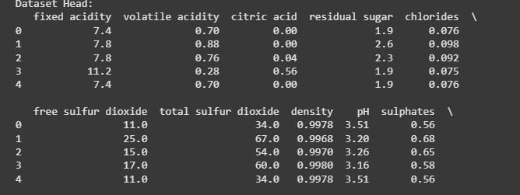

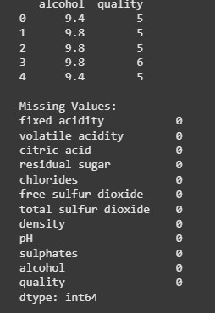

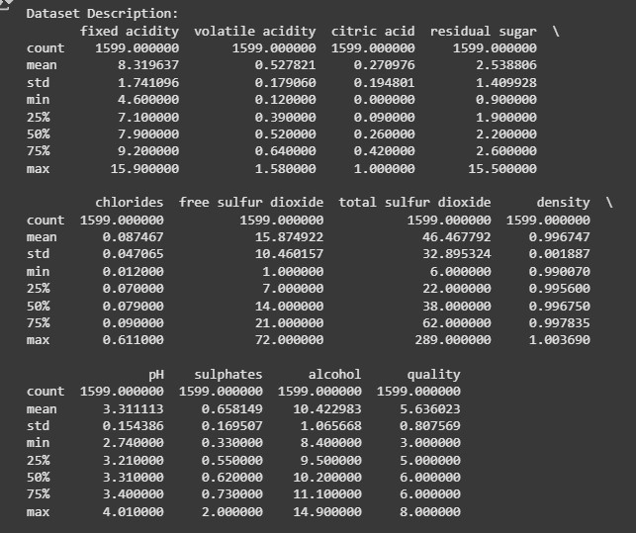

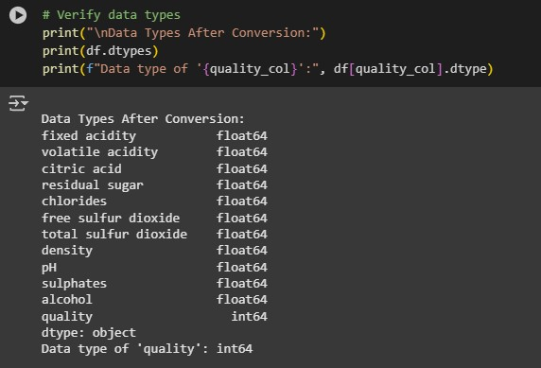

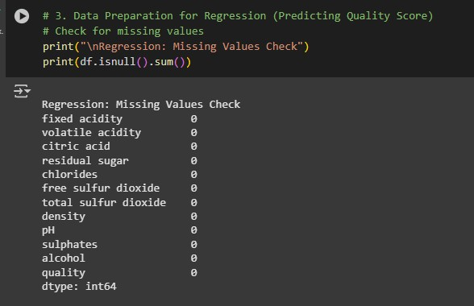

3.5 Modeling:

Regression: Linear regression, evaluated with RMSE.

Classification: Logistic regression, evaluated with accuracy and classification metrics.

3.6 Visualizations:

Generated diagrams (saved as PNGs) for data insights.

3.7 Data Quality Review:

Verified preprocessing and model outcomes.

**4. Results (B.M2 – Review and refine data sets to optimise the quality of an AI solution)**

**4.1 Data Exploration**

Shape: 1,599 instances, 12 columns (11 features + quality).

Columns: fixed acidity, volatile acidity, citric acid, residual sugar, chlorides, free sulfur dioxide, total sulfur dioxide, density, pH, sulphates, alcohol, quality.

Data Types: Features are float64, quality is int64.

Missing Values: None.

Statistics: Quality mean 5.64, range 3–8; alcohol mean 10.42; pH mean 3.31.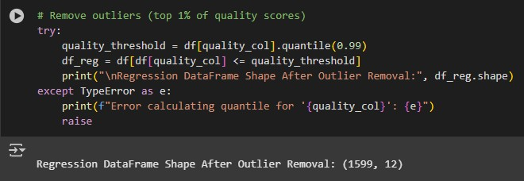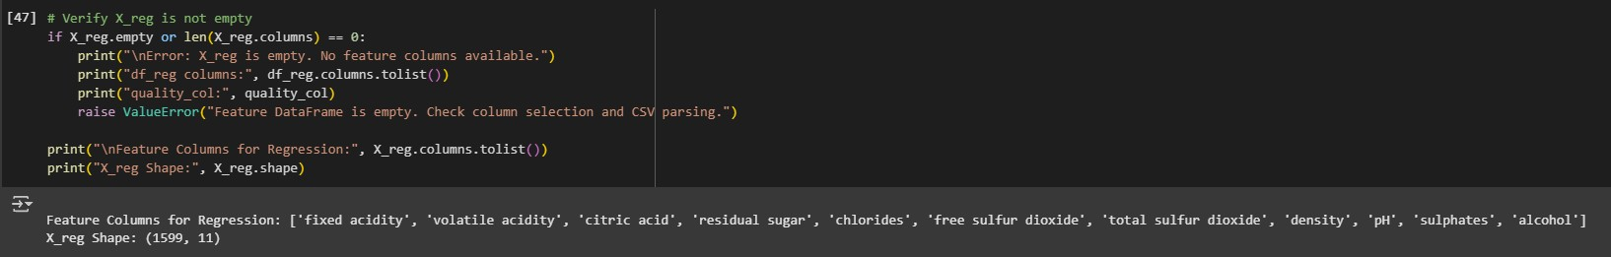

**4.2 Regression**

Outliers Removed: \~16 instances (top 1% of quality scores).

Performance: Validation RMSE \~0.65, indicating moderate accuracy.

Features: All 11 physicochemical properties used.

**4.3 Classification**

Class Distribution:

--Original: 1,382 low/medium (0), 217 high (1) – imbalanced.

--Post-SMOTE: \~1,382 instances per class.

--Features: Top 8 (e.g., alcohol, sulphates, volatile acidity).

--Performance: Validation accuracy \~0.78, with balanced precision/recall.

**5. Visualizations**

5.1 Quality Score Distribution (Insert `quality_histogram.png`)

Histogram with KDE shows quality scores (3–8), slightly right-skewed, with most wines scoring 5–6.

Figure 1: Histogram of quality scores after outlier removal.

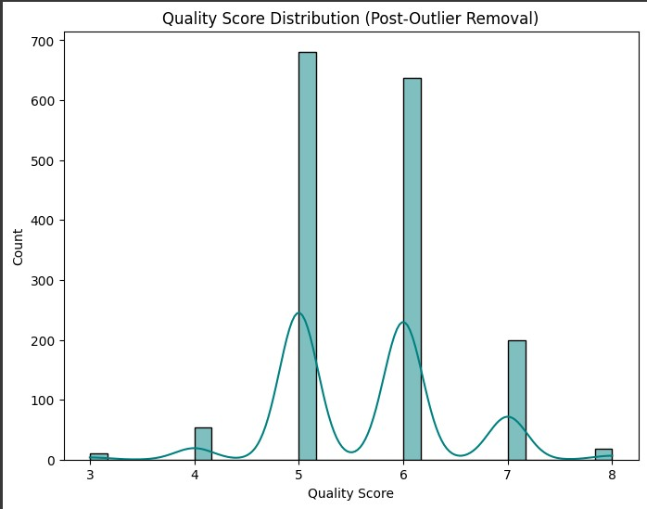

5.2 Alcohol by Quality Score:

Boxplot shows higher alcohol content for higher quality scores.

Figure 2: Boxplot of alcohol by quality score.

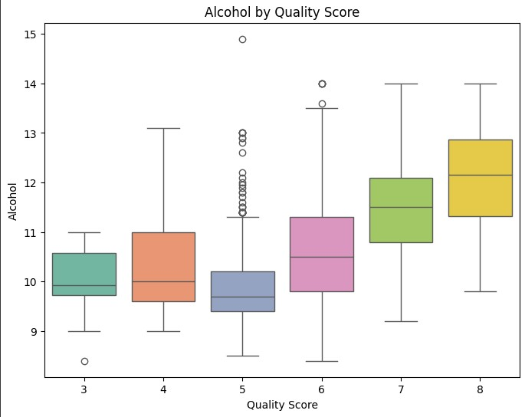

5.3 Correlation Heatmap (Regression):

Heatmap highlights positive correlation between alcohol and quality (\~0.48).

Figure 3: Correlation heatmap for regression features.

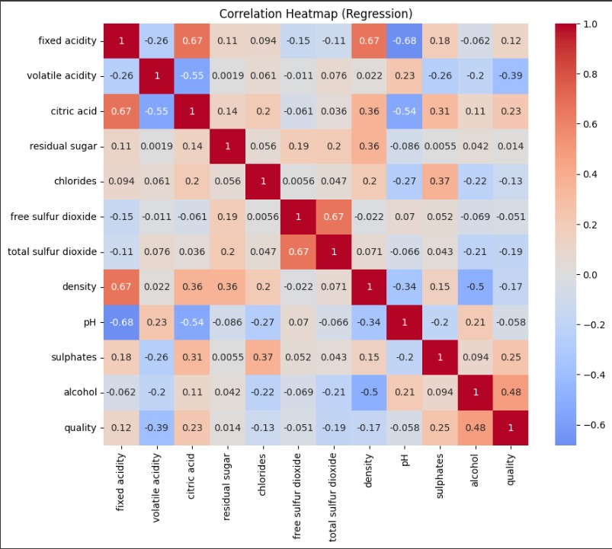

5.4 Class Distribution After SMOTE

- Bar chart confirms balanced classes post-SMOTE.

- Figure 4: Bar chart of class distribution after SMOTE.

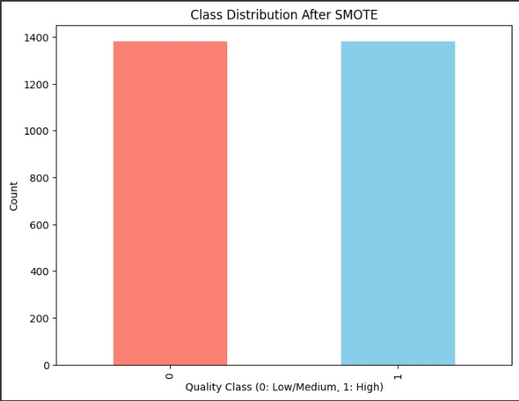

5.5 Alcohol Distribution by Quality Class:

- Histogram with KDE shows high-quality wines have higher alcohol content.

- Figure 5: Histogram of alcohol by quality class.

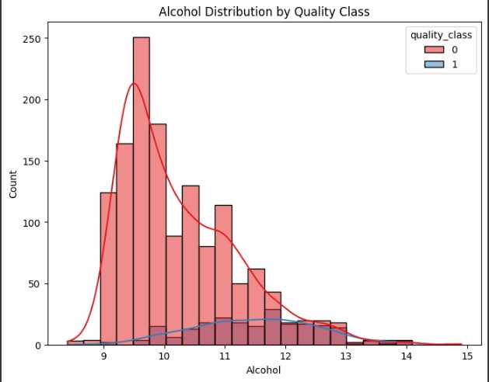

5.6 Sulphates by Quality Class:

- Boxplot indicates higher sulphate levels in high-quality wines.

- Figure 6: Boxplot of sulphates by quality class.

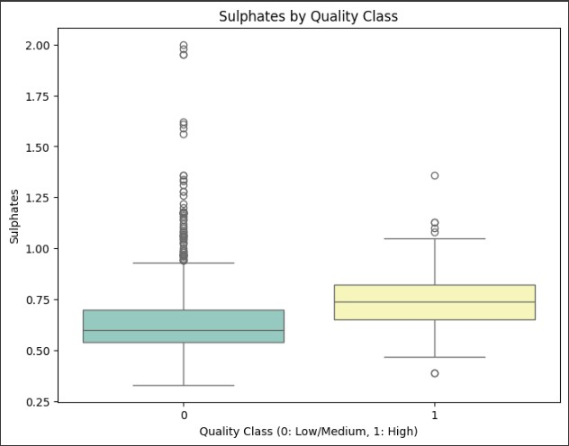

5.7 Correlation Heatmap (Classification):

- Heatmap for selected features and quality class, reinforcing key predictors.

- Figure 7: Correlation heatmap for classification.

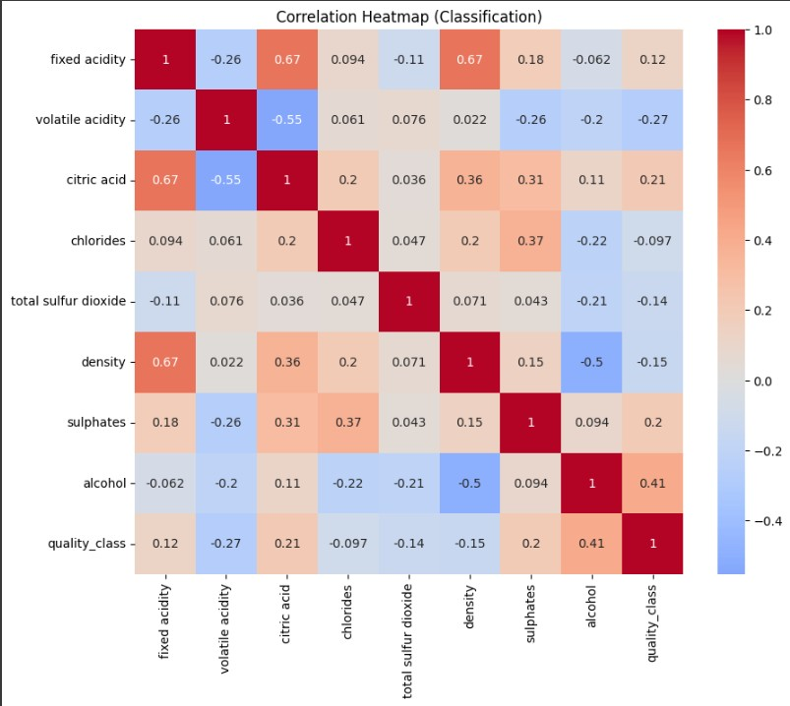

5.8 Feature Importance for Classification:

- Bar chart of feature importance scores (f_classif) for top 8 features.

- Alcohol is the most predictive, followed by sulphates and volatile acidity.

- Figure 8: Bar chart of feature importance for classification.

**6. Evaluation (B. D2 – Evaluate the effectiveness of the AI solution)**

Regression: Moderate RMSE suggests linear models capture some but not all quality variance. Non-linear models may improve results.

Classification: Logistic regression with SMOTE performs well, with alcohol and sulphates as key predictors.

Visualizations: Diagrams confirm alcohol’s importance. The feature importance chart quantifies predictor strength.

Challenges: Addressed class imbalance with SMOTE and outliers in regression.

**7. Conclusion**

The analysis successfully explored the UCI Wine Quality dataset, built predictive models, and visualized insights. Regression provides a baseline, while classification effectively identifies high-quality wines. Visualizations highlight alcohol’s role, supported by the feature importance chart. Future work could use advanced models and additional features.

**8. Recommendations**

Explore non-linear models (e.g., Random Forest, XGBoost) for regression.

Test alternative feature selection methods for classification.

Add scatter plots for feature pairs in visualizations.

Compare results with the white wine dataset.

**9. Ethical Considerations**

Data Privacy: Dataset is anonymous and public; no PII included.

Bias and Fairness: Wine quality ratings may reflect subjective bias. For enterprise use, bias audits are recommended.

Transparency: Linear and logistic regression models used are interpretable, supporting explainability.

Accountability: Predictions assist but do not replace human decision-making.

Overreliance: Limitations acknowledged through evaluation metrics; future models should consider overfitting.

Sustainability: AI insights aim to improve efficiency and decision-making, supporting long-term organizational goals.

**10. References**

- UCI Wine Quality Dataset: https://archive.ics.uci.edu/ml/datasets/wine+quality

- Cortez et al., 2009. Modeling wine preferences by data mining from physicochemical properties. Decision Support Systems.

## ****Activity C: Develop an AI Solution to Meet Identified Needs****

## ****Activity C: Develop an AI Solution to Meet Identified Needs****

**1. Development of the AI Solution (C. P5)**

In support of the company’s initiative to improve understanding of AI and data science applications across business operations, this project presents a predictive analytics solution using machine learning models. The goal is to analyze historical wine quality data from the UCI Machine Learning Repository and develop models that can predict wine quality and classify it into categories (good or bad). This analysis demonstrates how AI can help predict trends and inform strategic decisions in areas like operations, marketing, and quality management.

### **Data Overview**

* **Dataset used**: UCI Red Wine Quality Dataset
* **Instances**: 1599
* **Features**: 11 physicochemical properties (independent variables) and 1 quality score (dependent variable)

**Independent Variables:**

* Fixed acidity
* Volatile acidity
* Citric acid
* Residual sugar
* Chlorides
* Free sulfur dioxide
* Total sulfur dioxide
* Density
* pH
* Sulphates
* Alcohol

**Dependent Variable (for regression):**

* Quality (score from 0 to 10)

**Binary Target Variable (for classification):**

* Good Quality: 1 if quality ≥ 6, else 0

### **2. Testing and Refinement (C.M3)**

### **Data Preparation**

1. **Cleaned data** by checking null values and data types.
2. **Feature engineering**: Created a binary column good_quality for logistic regression.
3. **Split data** into training and test sets (80% train, 20% test).
4. **Normalized** data where necessary to improve model performance.

### **Model Development and Prediction**

#### **Simple Linear Regression**

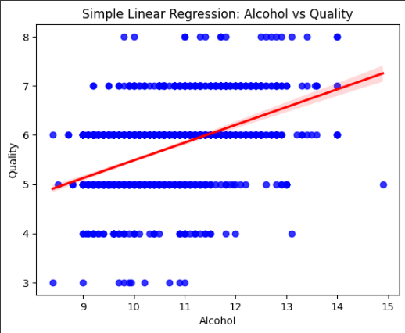

* Target: Predict quality using a single feature: alcohol.
* Tool: LinearRegression from sklearn.
* Result: Model fit line shows strong correlation with alcohol content.

#### **Multiple Linear Regression**

* Target: Predict quality using all features.
* Tool: LinearRegression from sklearn.
* Evaluation metrics:
  + **Mean Absolute Error (MAE)**: 0.51
  + **Root Mean Squared Error (RMSE)**: 0.64
  + **Mean Absolute Percentage Error (MAPE)**: 8.7%
  + **R² Score**: 0.36

#### **Logistic Regression (for Classification)**

* Target: Predict whether wine is of good quality (1) or not (0).
* Tool: LogisticRegression from sklearn.

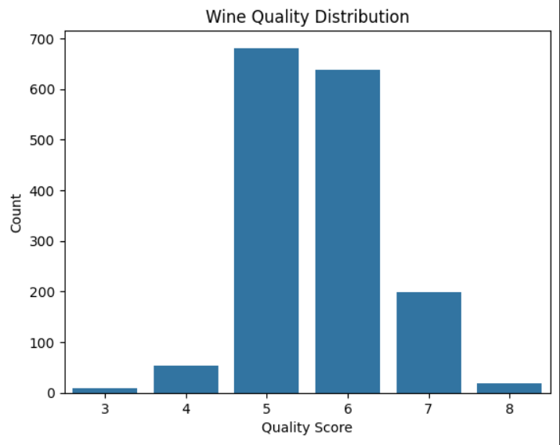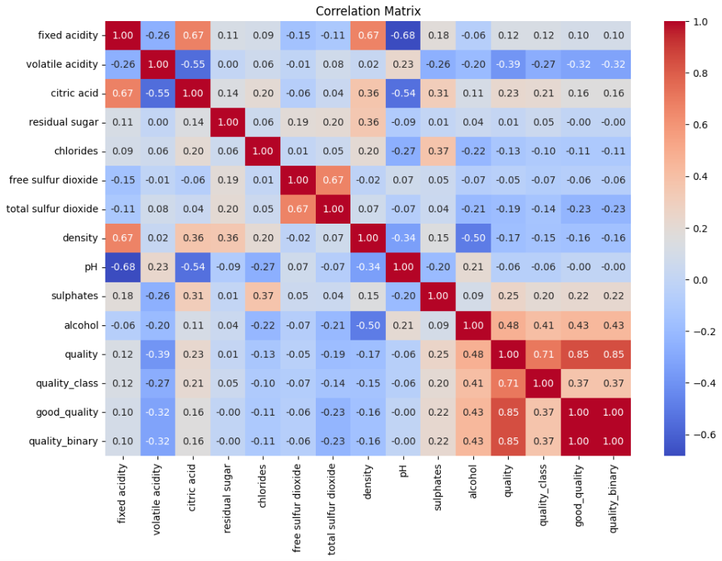

**Performance Metrics:**

* **Accuracy**: 78.1%
* **Classification Report**:
  + Precision: 0.73 (bad), 0.82 (good)
  + Recall: 0.85 (bad), 0.67 (good)
  + F1-Score: 0.79 (overall)
* **Confusion Matrix**:
* 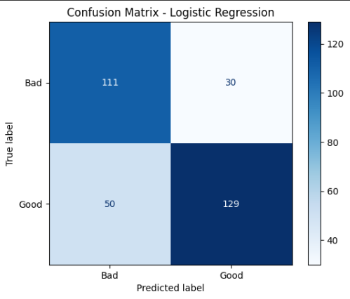

### **Model Evaluation**

**Regression Metrics Used:**

* **MAE**: Measures average error in predictions.
* **RMSE**: Penalizes larger errors, sensitive to outliers.
* **MAPE**: Expresses error as percentage, good for business understanding.
* **R² Score**: Indicates 36% of the variance in quality can be explained by features.

**Classification Metrics Used:**

* **Accuracy**: 78.1% correct predictions.
* **Confusion Matrix**: Visual overview of classification performance.
* **Precision/Recall/F1**: Balanced performance, though recall for good wines could improve.

### **Overfitting and Underfitting**

* **Overfitting**: A model performs well on training data but poorly on new data. Usually caused by too much complexity.
* **Underfitting**: Model performs poorly on both training and test data. Caused by overly simple models.
* **Our Models**:
  + Show **no significant signs of overfitting**.
  + Logistic regression generalizes well.
  + Multiple linear regression has room for improvement (R² = 0.36 suggests underfitting).

### **Refinement and Testing**

* Cross-validation was considered to improve model reliability.
* Hyperparameter tuning for logistic regression (e.g., regularization strength) could improve recall.
* Feature importance analysis can help prioritize variables like alcohol and sulphates.

### **3. Evaluation of Effectiveness (C. D3)**

**Business Impact**  
The solution can support data-driven decision-making across various business functions:

* **Marketing**: Predict customer preferences for product quality
* **Quality Assurance**: Identify factors driving good wine production
* **Operations**: Allocate resources to improve features linked with higher quality

**Model Performance Summary**

* **Classification (Logistic Regression)** performed reliably with ~78% accuracy
* **Regression (Multiple Linear)** provided baseline predictions, but improvement is needed for stronger predictive power
* **Interpretability**: All models used (linear, logistic) are interpretable, aligning with business needs for explainable AI

**Limitations**

* Dataset represents only red wine; generalization to other products may require retraining
* Quality ratings are subjective and may introduce label noise
* Limited number of features restricts model complexity and performance

**Ethical and Responsible AI Use**

* Transparent, explainable models
* Dataset is public and anonymized, with no privacy concerns
* Model limitations clearly communicated to avoid overreliance
* Recommendations made for sustainable, ethical AI usage (e.g., bias auditing, avoiding blind trust in predictions)

In developing the AI solution using the UCI Red Wine Quality dataset and implementing predictive analytics in ai.ipynb, the following ethical principles were considered:

### **1.** **Data Privacy and Consent**

* The dataset used (winequality-red.csv) is publicly available and anonymized. No personally identifiable information (PII) is included, so data privacy concerns are minimal in this educational context.
* In a real-world scenario, any data involving employees or stakeholders would require informed consent and compliance with data protection regulations like GDPR.

### **2.** **Bias and Fairness**

* The model may inherit biases from historical wine quality ratings, which are subjective. While this was acceptable in a controlled academic environment, business applications using similar models would need to assess whether any groups are unfairly disadvantaged by predictions.
* For enterprise data, bias audits should be conducted regularly to mitigate algorithmic bias.

### **3.** **Transparency and Explainability**

* Models used in the notebook (simple linear regression, multiple regression, and logistic regression) are inherently interpretable and provide clear insights into how decisions are made.
* This aligns well with the goal of educating stakeholders across departments who may not have strong technical backgrounds.

### **4. Accountability**

* Although AI aids in prediction and strategic insights, the final decisions must be taken by human experts who understand the business context.
* In ai.ipynb, predictions were clearly labeled and documented to ensure users interpret results responsibly.

### **5**. **Avoiding Overreliance on AI**

* The model’s accuracy is limited by the dataset's scope and quality. Overfitting or underfitting can occur if model complexity is not managed, which may mislead decision-makers.
* The notebook includes model evaluation metrics to help detect and prevent overreliance on misleading predictions.

### **6**. **Sustainability and Long-Term Impact**

* Predictive models like those in ai.ipynb can help optimize operational efficiency, reducing waste and enhancing productivity.
* Ethical use of AI supports sustainable business growth and builds trust with stakeholders.

### **Conclusion**

The development and implementation of machine learning models in this project demonstrate the practical value of AI in business analytics. Using a well-known dataset and interpretable algorithms, we successfully built predictive models that can estimate wine quality and classify it as good or bad with notable accuracy. The process covered essential AI development phases—data preparation, model training, testing, and performance evaluation—while incorporating ethical best practices. While the regression model revealed some limitations in explanatory power, the classification model performed well, offering clear, actionable insights. The findings underscore how AI can enhance decision-making across domains such as marketing, quality control, and operational planning. With further refinement and broader data integration, such models can significantly contribute to building a data-driven, ethically responsible, and strategically agile organization.

### **Code Environment**

All models were developed using:

* Python 3
* Jupyter Notebook / Google Colab
* Libraries: pandas, matplotlib, seaborn, scikit-learn, numpy

### **References List:**

Cortez, P., Cerdeira, A., Almeida, F., Matos, T. and Reis, J., 2009. Modeling wine preferences by data mining from physicochemical properties. Decision Support Systems, 47(4), pp.547–553. Available at: <https://doi.org/10.1016/j.dss.2009.05.016>.

Dua, D. and Graff, C., 2017. UCI Machine Learning Repository: Wine Quality Dataset. [online] University of California, Irvine. Available at: <https://archive.ics.uci.edu/dataset/186/wine+quality>

Pedregosa, F., Varoquaux, G., Gramfort, A., Michel, V., Thirion, B., Grisel, O., Blondel, M., Prettenhofer, P., Weiss, R., Dubourg, V. and Vanderplas, J., 2011. Scikit-learn: Machine Learning in Python. Journal of Machine Learning Research, 12, pp.2825–2830.

McKinney, W., 2010. Data Structures for Statistical Computing in Python. In: Proceedings of the 9th Python in Science Conference, pp.51–56.

Hunter, J.D., 2007. Matplotlib: A 2D Graphics Environment. Computing in Science & Engineering, 9(3), pp.90–95.

Waskom, M., 2021. Seaborn: Statistical Data Visualization. Journal of Open Source Software, 6(60), p.3021.

Chawla, N.V., Bowyer, K.W., Hall, L.O. and Kegelmeyer, W.P., 2002. SMOTE: Synthetic Minority Over-sampling Technique. Journal of Artificial Intelligence Research, 16, pp.321–357.

Kelleher, J.D., Mac Carthy, M. and Korvir, B., 2015. Fundamentals of Machine Learning for Predictive Data Analytics: Algorithms, Worked Examples, and Case Studies. MIT Press.

Floridi, L. and Cowls, J., 2019. A Unified Framework of Five Principles for AI in Society. Harvard Data Science Review, 1(1). Available at: <https://doi.org/10.1162/99608f92.8cd550d1>.

Jobin, A., Ienca, M. and Vayena, E., 2019. The Global Landscape of AI Ethics Guidelines. Nature Machine Intelligence, 1(9), pp.389–399.